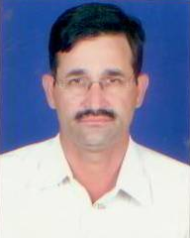

Name : Sh. S. A Raja
Designation : Sr. Scientist
Area of Specialization : Hydrology
Qualification : M.Sc. (Geology)
Total Experience : More than 24 years

