**2.**

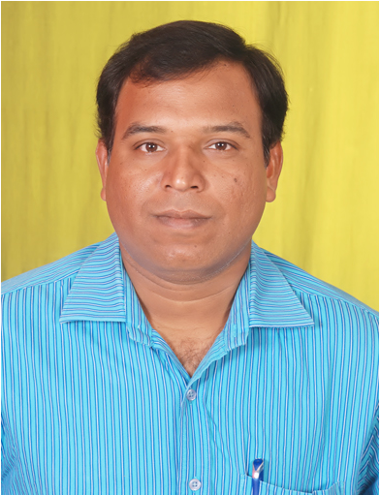

**Name : Dr. Rakesh Kumar Arya**

**Designation : Senior Resource Scientist**

**Area of Specialization : Computational Technology**

**Qualification : P.G.: Electronics and Communication Engineering**

**Ph.D.: Electronics and Computer Engineering**

**Total Experience : More than 15 years**