**18.**

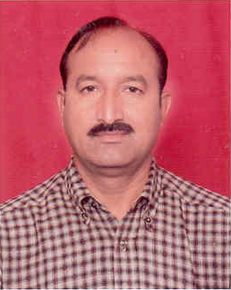

**Name : Dr. Praveen Digharra**

**Designation : Sr. Scientist**

**Area of Specialization : Geospatial Technology**

**Qualification : P.G.: Geograph, Ph.D.**

**Total Experience : More than 23 years**